INF 1103 Lab 2 Submission:
1: Python file (auditor.py) ✅
2: Git Log (I just commit once, so I paste the screenshot here if that’s okay)
3: https://github.com/JunLongSIT/INF1103-Lab2/commit/6500db17fee59d18ec4d6067021653e48490b3bc
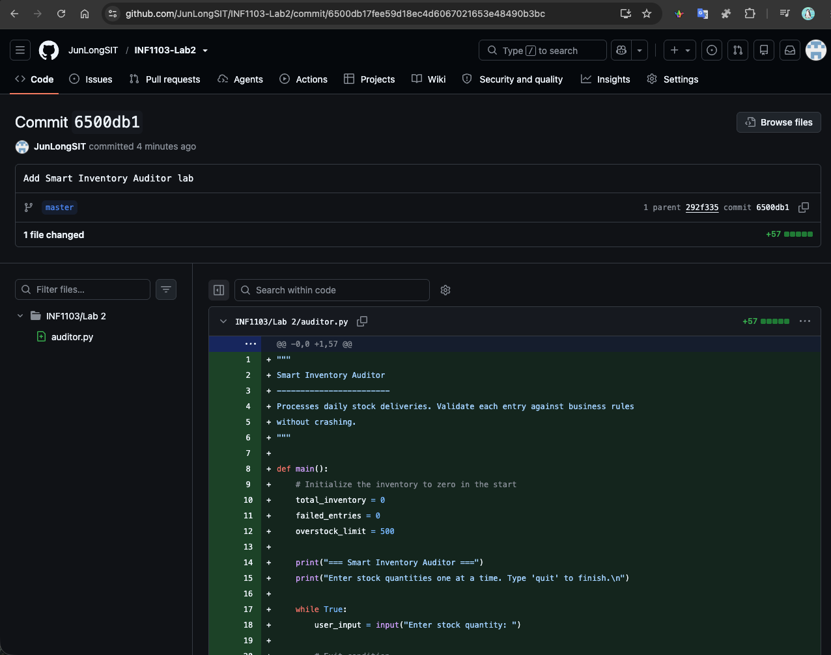

4: Docker Mount and Run
Building my custom Image:
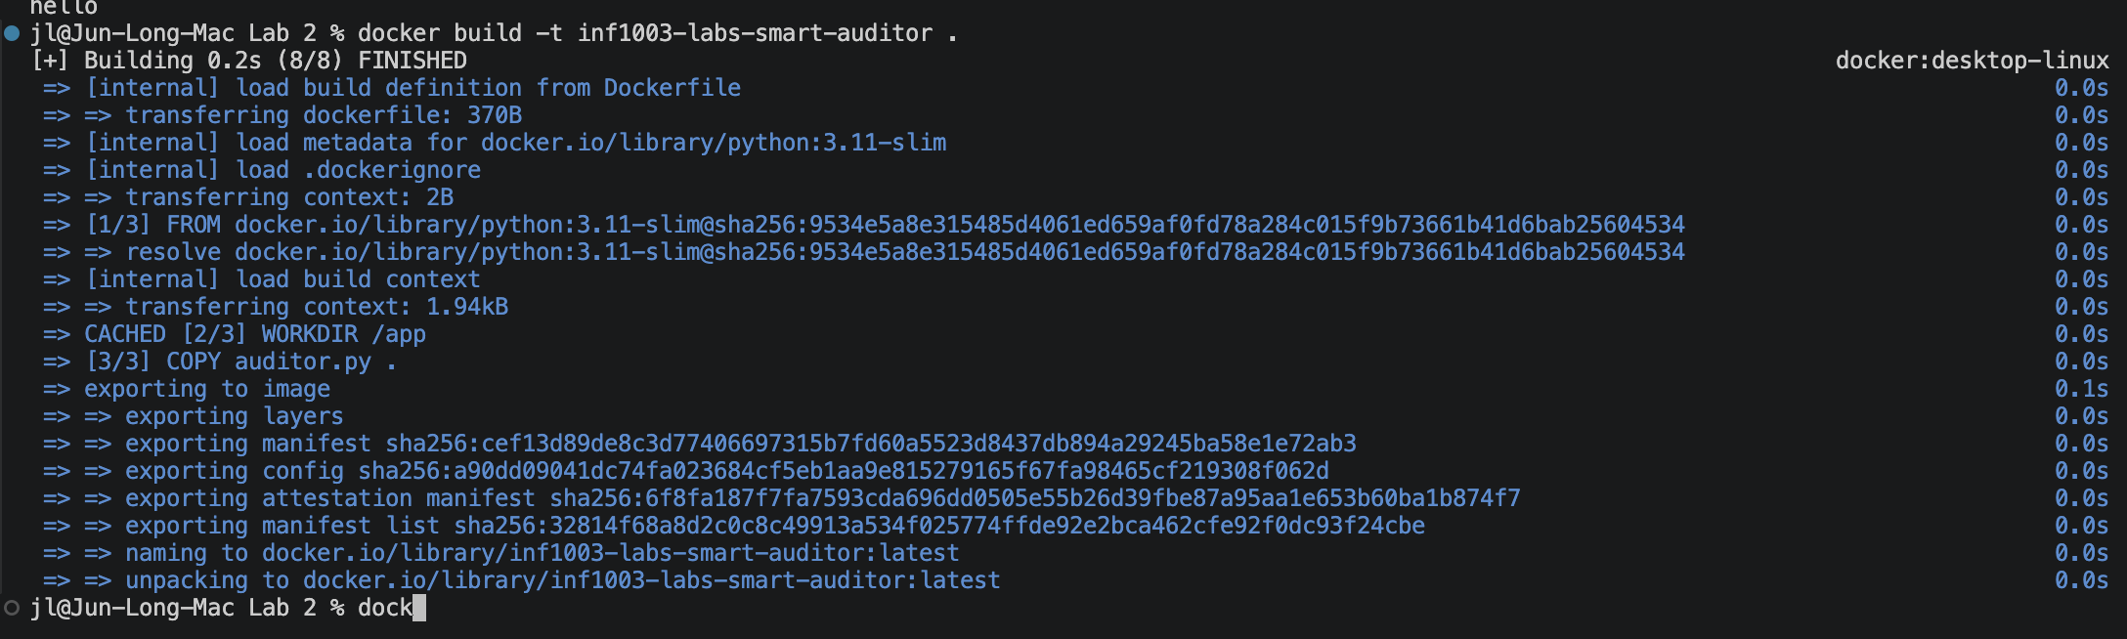

5: Evidence of image successfully built:

6: Proof of my auditor.py run successfully by accepting input and producing results.
